Epsom & Ewell F.C.
17
v
Camberley Town
Saturday, 7th February 2015
For our League match this afternoon we welcome the players and officials of our old friends from Camberley Town along with today's match officials and of course our own regular supporters.

Our opponents need no introduction as we meet for the 85th time today and of course compete against each other regularly. It was only two months ago that they were here for a Surrey Senior Cup tie and we will meet at High Road for a third time in a League Cup Quarter Final contest in just seventeen days!

Our regular meetings are in danger though, as the Krooners lead the table and are in pole position for a League and Cup double this term. Our boys have the chance to dent their hopes in the former and deny them in the latter, so we should see some competitive and entertaining football as a result.

It doesn’t always work like that though, and it must be said that our two meetings so far, both of which resulted in 1-0 victories for the home side, were not particularly exciting to watch. In fact Camberley have been picking up a bit of unfair press on this matter, with criticism of what is classed as their “direct” style. Personally, I belong to the school that says “if it works, do it” and leave it to the opponents to find a way to stop it!

We are today playing our first match for eighteen days as a result of a very rare home postponement last Saturday against Westfield. The pitch here is like a sponge when it is wet, but it does get rather cold at times, and the snow covering just wouldn’t melt away in time. It wasn’t all bad though as we actually went up a place in the table following Colliers Wood’s 4-1 defeat at Ashford Town! Next Saturday we make the short journey to Raynes Park Vale, while seven days later Hartley Wintney visit us back here.

We are still looking for match and player sponsors, while the Salts Super Six Predictor jackpot is now up to £195 just for getting six results right. We had ten people who got five out of the six correct last time, while no tickets were sold last weekend. The big prize remains elusive for now but for how much longer….

Thanks for watching today. Glyn, the lads and our officials value your support.

Rich

Cover photo this week by Gemma Jarman

Matt Robinson celebrates his long range strike which put us ahead at Molesey in the Surrey Senior Cup eleven days ago

Cherry Red Records
Combined Counties League
Premier Division Table 2014/15
inc Wednesday  4th February 2015 | P | W | D | L | F | A | Pts | GD | H | A
Camberley Town | 25 | 19 | 3 | 3 | 61 | 17 | 60 | +44 | 7/2 | 0-1
Cove | 27 | 18 | 5 | 4 | 64 | 42 | 59 | +22 | 7/3 | 0-1
Molesey | 23 | 18 | 0 | 5 | 68 | 20 | 54 | +48 | 1-3 | 28/2
Windsor | 27 | 17 | 3 | 7 | 66 | 35 | 54 | +31 | 0-5 | 11/4
Ashford Town (Mx) | 27 | 18 | 2 | 7 | 64 | 33 | 56 | +31 | 2-4 | 3-1
Spelthorne Sports | 25 | 15 | 2 | 8 | 56 | 39 | 47 | +17 | 4-3 | 3-0
Hartley Wintney | 26 | 13 | 4 | 9 | 36 | 41 | 43 | -5 | 21/2 | 1-2
Badshot Lea | 26 | 12 | 4 | 10 | 56 | 45 | 40 | +11 | 21/3 | 2-4
Farnham Town | 25 | 10 | 5 | 10 | 55 | 59 | 35 | -4 | 2-4 | 2-0
Mole Valley SCR | 26 | 10 | 5 | 11 | 49 | 60 | 35 | -11 | 1-0 | 5-2
Epsom & Ewell | 25 | 10 | 2 | 13 | 46 | 47 | 32 | -1 | - | -
Colliers Wood United | 26 | 10 | 2 | 14 | 46 | 48 | 32 | -2 | 4/4 | 2-3
Bedfont Sports | 24 | 9 | 3 | 12 | 33 | 45 | 30 | -12 | 0-1 | 2-0
Chertsey Town | 26 | 9 | 3 | 14 | 40 | 55 | 30 | -15 | 1-2 | 14/3
Raynes Park Vale | 24 | 7 | 5 | 12 | 33 | 44 | 26 | -11 | 0-1 | 14/2
Knaphill | 24 | 7 | 5 | 12 | 30 | 56 | 26 | -26 | 18/4 | 4-1
Westfield | 24 | 6 | 5 | 13 | 35 | 48 | 23 | -13 | 24/3 | 0-4
Horley Town | 26 | 6 | 5 | 15 | 47 | 70 | 23 | -23 | 2-2 | 6/4
Frimley Green | 27 | 5 | 4 | 18 | 44 | 76 | 19 | -32 | 0-0 | 25/4
Hanworth Villa | 24 | 4 | 5 | 15 | 31 | 51 | 17 | -20 | 3/3 | 5-2
Guildford City | 23 | 5 | 2 | 16 | 38 | 67 | 17 | -29 | 4-1 | 28/3

Lucky Day? – 7th February
Played 14 - Won 5 Drawn 4 Lost 5 - F 19 A 31 - PPG 1.36 - Average
Club record against Camberley Town
Played 84 - Won 38 Drawn 20 Lost 25 Abandoned 1
F 151 A 111 - PPG 1.61 - Above Average
Last visit
Tuesday 2nd December 2014 - Won 1-0 - Surrey Senior Cup

Anthony Panayi
Good afternoon!

Today we welcome Camberley Town to Hgh Road in what should be another good game.

After the disappointment last week of getting knocked out of the Surrey Senior Cup we are looking forward to getting back to winning ways!

Over the next few weeks we will have a few players back from suspensions and injuries something which has cost us this season.

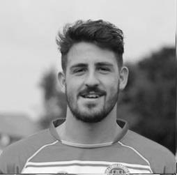
On that note all the boys want to say a big well done to 'trig' a.k.a. George Murphy for continuing to play through a double hernia! George will be missed in the team for the time he will be out for! We wish him a speedy recovery!

Thank you for your continued support!

COME ON YOU SALTS!

Ant

Results and Fixtures
F.A. Vase Fourth Round – Saturday 17th January
Ascot United | 4-2+ | Colliers Wood United
Combined Counties League – Saturday 17th January
Ashford Town (Mx) | 1-2 | Westfield
Cove | 1-3 | Badshot Lea
Epsom & Ewell | 2-4 | Farnham Town
Horley Town | 1-2 | Windsor
Mole Valley SCR | 0-4 | Chertsey Town
Raynes Park Vale | 1-1 | Hartley Wintney
Spelthorne Sports | 2-0 | Knaphill
Surrey Senior Cup Third Round – Tuesday 20th January
Molesey | 3-1 | Epsom & Ewell
Combined Counties League – Saturday 24th January
Badshot Lea | 3-0 | Ashford Town (Mx)
Camberley Town | 3-1 | Bedfont Sports
Chertsey Town | 0-3 | Spelthorne Sports
Hanworth Villa | 2-2 | Knaphill
Hartley Wintney | 3-1 | Frimley Green
Horley Town | 2-2 | Cove
Raynes Park Vale | 2-3 | Mole Valley SCR
Windsor | 2-4 | Farnham Town
Results and Fixtures
Surrey Senior Cup Third Round – Tuesday 27th January
Redhill | 0-2 | Westfield
Combined Counties League Cup Third Round – Tuesday 27th January
Farnham Town | 2-0 | Mole Valley SCR
Worcester Park | 6-1 | Banstead Athletic
Game played at Colliers Wood United
Combined Counties League – Tuesday 27th January
Cove | 3-0 | Frimley Green
Molesey | 3-1 | Windsor
Combined Counties League – Wednesday 28th January
Colliers Wood United | 0-1 | Camberley Town
Combined Counties League – Saturday 31st January
Ashford Town (Mx) | 4-1 | Colliers Wood United
Frimley Green | 2-3 | Hanworth Villa
Combined Counties League – Tuesday 3rd February
Spelthorne Sports | 4-0 | Horley Town
Combined Counties League – Saturday 7th February
Ashford Town (Mx) | V | Hartley Wintney
Badshot Lea | V | Spelthorne Sports
Chertsey Town | V | Bedfont Sports
Colliers Wood United | V | Knaphill
Cove | V | Mole Valley SCR
Epsom & Ewell | V | Camberley Town
Farnham Town | V | Molesey
Guildford City | V | Horley Town
Raynes Park Vale | V | Hanworth Villa
Windsor | V | Westfield
Combined Counties League Cup Third Round – Tuesday 10th February
Westfield | V | Cove
Combined Counties League – Tuesday 10th February
Chertsey Town | V | Colliers Wood United
Farnham Town | V | Raynes Park Vale
Combined Counties League – Wednesday 11th February
Guildford City | V | Knaphill
Combined Counties League – Saturday 14th February
Badshot Lea | V | Guildford City
Results and Fixtures
Combined Counties League – Saturday 14th February
Camberley Town | V | Windsor
Cove | V | Chertsey Town
Hanworth Villa | V | Colliers Wood United
Hartley Wintney | V | Bedfont Sports
Knaphill | V | Frimley Green
Molesey | V | Ashford Town (Mx)
Raynes Park Vale | V | Epsom & Ewell
Spelthorne Sports | V | Farnham Town
Westfield | V | Horley Town
Surrey Senior Cup Q-F – Tuesday 17th February
Ashford Town (Mx) | V | Westfield
Combined Counties League – Tuesday 17th February
Bedfont Sports | V | Mole Valley SCR
Knaphill | V | Spelthorne Sports
Combined Counties League – Wednesday 18th February
Guildford City | V | Molesey
Combined Counties League – Saturday 21st February
Bedfont Sports | V | Cove
Chertsey Town | V | Hanworth Villa
Colliers Wood United | V | Molesey
Epsom & Ewell | V | Hartley Wintney
Frimley Green | V | Camberley Town
Horley Town | V | Badshot Lea
Mole Valley SCR | V | Ashford Town (Mx)
Guildford City | V | Farnham Town
Spelthorne Sports | V | Raynes Park Vale
Windsor | V | Knaphill
Combined Counties League Cup Q-F – Tuesday 24th February
Epsom & Ewell | V | Camberley Town
Combined Counties League – Tuesday 24th February
Farnham Town | V | Ashford Town (Mx)
Hartley Wintney | V | Guildford City
Raynes Park Vale | V | Molesey
Combined Counties League Cup Q-F – Wednesday 25th February
Colliers Wood United | V | Badshot Lea

From behind the goal
Epsom & Ewell 2-4 Farnham Town
Combined Counties League - Saturday 17th January 2015

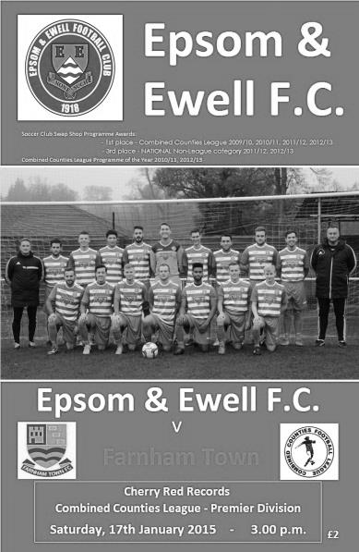
Consistency proving elusive for Salts

Saturday's home defeat to in-form Farnham Town ensures that our last six matches have finished; win, loss, win, loss, win, loss! Extended further, after 22 games under Glyn Mandeville we have won eleven and lost eleven with an even goal difference!

At least the line-up was consistent as we named an unchanged side, following our fine win at Ashford Town and hopefully could take any momentum from that game into this latest match. Unfortunately Farnham hadn't read the script and produced a fine performance of their own, full of attacking pace and threat, the like of which we hadn't come up against since visiting Lingfield in November.

The opening exchanges were even and we could have gone ahead in the seventh minute when Daryl Cooper-Smith sent a pinpoint pass from twenty yards into the path of Savva "Agi" Panayiotou. As he advanced on goal he chose to shoot from just inside the box and went high instead of low but keeper Danny Leeds was able to deflect the shot just over the bar. From the corner the ball dropped to George Murphy who timed his shot perfectly, but unfortunately for him and the crowd, his strike fizzed a matter of inches wide of the top corner.

Next in action was Michael Eacott who had to be alert to block an effort from down the left wing but he had no chance in the 15th minute when a low right wing cross was headed in at the near post by John Lancashire. This was a disappointing start but it was almost instantly forgotten by the majority of the crowd as Cooper-Smith advanced on goal and from at least 25 yards struck a low shot that visibly swerved away from the keeper and into the bottom corner of the net. As at Ashford seven days previously we had dealt with conceding in the very best way, with a lightning quick response of our own.

Could we take advantage of the equaliser? Ultimately no. The visitors upped their game and started to attack us, mostly down the right flank where Steve Rowe was getting two players on him for virtually the remainder of the half and we didn't seem able to help him out. We had a warning after 32 minutes when a ball in from that area was met beyond the far post by a powerful strike that flew off our post and went out for a throw

on!

The warnings weren't heeded though and from yet another attack down our left flank the ball was held up and laid back for Mark Corbett to knock the ball into the far corner. We were up against it at this point as the visitors began to take full control. Another shot was deflected over the bar for a corner while another shot just moments later was blocked out for a corner by Anthony Panayi. However, on the counter attack in the 41st minute, a break down the left was laid back to Alex McKay who controlled the ball on the edge of the area and smashed the ball into the bottom corner with the keeper seeing the ball late.

Another scare came right on half time when a Farnham striker got through just ahead of Murphy and bore down on goal but Eacott did well to make an intervention with his leg, and although the striker was first to the loose ball and shot goalwards, Murphy had positioned himself on the line to make a right footed clearance.

You could argue that being level at half time was fortunate and bearing in mind that we actually trailed at half time on Farnham's two previous visits it was almost a bonus. We started the second half in a positive fashion but didn't really create too much and that would come back to haunt us later in the match. Cooper-Smith prodded the ball inches wide of the far post and an Alex McGregor free kick was curled just beyond the Farnham far post with the keeper beaten but after 68 minutes the visitors got away again on the right and a good overlapping run by the full back resulted in a low near post cross and although we were alert to block the incoming shot from Lancashire, the ball fell kindly for him to knock it into the net from close range.

The returning Robbie Burns made an entrance along with Ali Dewar as we replaced Matt Robinson and the injured Kyle Hough who had been having rough days, but after78 minutes Eacott was in action once again, denying the left winger and a minute later they had their fourth goal as Elliott Cardona was able to benefit from yet another low right wing cross to the near post.

Matt Farrell entered the fray for Murphy and Panayiotou had a shot deflected wide for a corner but in truth we didn't create as much as the visitors who were fully deserving of the three points over the ninety minutes and left the Salts looking for that elusive consistency which threatens to leave us right in the middle of the table

Team:
Michael Eacott, James Taylor, Steve Rowe, Anthony Panayi ©,
George Murphy, Savva Panayiotou, Alex McGregor, Alex McKay, Kyle Hough,
Daryl Cooper-Smith, Matt Robinson

Subs:
Ali Dewar for Robinson (74), Robbie Burns for Hough (74),
Matt Farrell for Murphy (79)

From behind the goal
Molesey 3-1 Epsom & Ewell
Surrey Senior Cup Third Round - Tuesday 20th January 2015

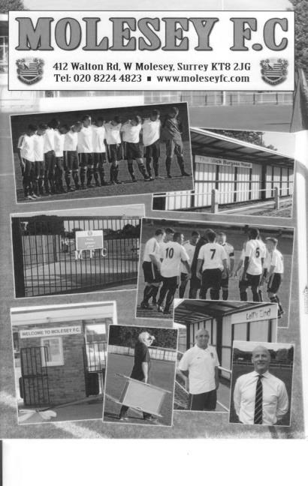
Moles wear Salts down in chilly cup tie

Molesey deservedly won this rearranged Surrey Senior Cup tie at a very cold Walton Road. However, with six minutes of normal time remaining the score was level and the tie could have gone either way.

We were able to include Matt Ferdinando in the line-up following the completion of his three match suspension although up front Kyle Hough was unable to get to the ground in time and this forced Glyn Mandeville into a change of plan up front, with Daryl Cooper-Smith leading the line and Alex McGregor playing behind him in a free role. Ferdinando and Matt Robinson took the wide berths in a 4-4-2 which looked quite threatening.

All we had to do now was to get hold of the ball, which proved quite difficult to start with. In fact Captain Anthony Panayi had to block a goalbound shot from close range in the first minute or we'd have got off to a horrible start. Another saving challenge on the left hand side of the defence restricted the home side to a corner as they came out with all guns blazing, probably frustrated at their late postponement on Saturday.

However, we began to weather the storm and got forward ourselves from time to time. James Taylor, making his 50th appearance produced a couple of crosses on a full back overlap as he linked well with Ferdinando and the prompting McGregor. However a few minutes later we were fortunate that a misplaced pass from a Molesey striker ran through to Michael Eacott instead of finding his well-placed team mate.

In the 27th minute we took the lead. Good work out on the right enabled the Molesey defence to get dragged over and the ball came to Robinson, who cut outside a covering defender and from the edge of the box unleashed a powerful shot that flew into the net off the far post. You could hear that there was a slight deflection on the shot but it was only a faint one and we were ahead. Unfortunately we were pushed back almost immediately, conceding a couple of corners, and from the second of these, Tom Windsor scored with a close range header while our players were claiming a foul on Eacott. The home side were getting the benefit of the decisions at this stage with a

couple of cynical fouls to stop Ferdinando runs going unpunished, while Cooper-Smith picked up the only yellow card of the opening forty five minutes for a challenge that appeared slightly late but happened right under the noses of the Molesey bench with predictable consequences.

Robinson tried his luck with a couple more long range efforts, although one was saved and one was wide, while McGregor curled a free kick over the bar, but on balance the home side shaded the first half which ended with the referee talking to Lewington the Molesey captain about the number of fouls they were conceding.

We had to make an early change in the second half with Steve Rowe limping off and being replaced by Ali Dewar. Versatile Dewar may be, but I think this was his first attempt for us at left back, which was also ironic as we had three to choose from in that position not so long ago. The home side appeared unlucky to get pulled up on an offside call while Robinson was again unfortunate to see his well struck shot just go beyond the far post after some good work by our midfield. This was quite a good time for us, although we created little of real threat, but the game was more even for a while.

As we entered the last twenty minutes the game became one of attack and counter attack. The home side pushed forward and Eacott did well to block a shot at the far post, but they were vulnerable to the break, and from one of these McGregor put Cooper-Smith through, but as he beat his man he was brought down by the Molesey number 2, and only the presence of a nearby covering defender ensured that the card was just a yellow one. McGregor then put a shot wide after Robinson's free kick was blocked to him.

Hough came on for the tiring Ferdinando but within a minute the home side had struck the killer blow, spreading the ball out wide to Windsor who scored his second of the night with a low drive into Eacott's far corner, and a third goal followed three minutes into injury time when we failed to control the ball in defence and it was fed back and then knocked past Eacott by James McShane before we could recover. Overall we have had two matches against Molesey now and both have seen us fall just a little short. They are a decent side that will almost certainly be right there at the end of the season. As for us, we get another chance at them in late February but now have eleven days off before hosting Westfield on 31st January.

Team: Michael Eacott, James Taylor, Steve Rowe, Anthony Panayi ©,
George Murphy, Savva Panayiotou, Matt Ferdinando, Matt Farrell,
Daryl Cooper-Smith, Alex McGregor, Matt Robinson

Subs: Ali Dewar for Rowe (50), Kyle Hough for Ferdinando (83)

Club Records - 7th February
Date | Day | Competition |  | Opponents |  | Scorers
07/02/25 | Sat | Surrey Senior League | H | Walton | 2-2 | S.Bristow, J.Parr
07/02/31 | Sat | London League | H | Carshalton Athletic | 7-1 | G.Prestoe (3), H.Pattimore (3), G.Mackesy
07/02/48 | Sat | London League | A | Chelmsford City Reserves | 0-14
07/02/53 | Sat | Corinthian League | H | Maidstone United | 4-2 | R.Walker (2), B.Brumwell, R.Ruffell
07/02/59 | Sat | Corinthian League | A | Dagenham | 0-4
07/02/70 | Sat | Athenian League 2 | A | Eastbourne | 0-0
07/02/76 | Sat | Athenian League 2 | A | Windsor & Eton | 0-0
07/02/81 | Sat | Isthmian League 1 | H | Ware | 0-1
07/02/84 | Tue | Isthmian League 1 | A | Hampton | 0-0
07/02/87 | Sat | Surrey Senior Cup 1 | A | Met Police | 2-1 | R.Purvis, T.Tuite
07/02/89 | Tue | Surrey Senior Cup QF | H | Whyteleafe | 1-0 | C.Hadingham
07/02/98 | Sat | Isthmian League 3 | A | Hemel Hempstead Town | 0-1
07/02/04 | Sat | Isthmian League 1s | H | Walton & Hersham | 0-3
07/02/13 | Thur | Combined Counties Premier Division | A | Chessington & Hook United | 3-2 | R.Burns (2), M.Jarman
Historical Decades
90 years ago – Epsom Town
07/02/25 | Sat | Surrey Senior League | H | Walton | 2-2 | S.Bristow, J.Parr
80 years ago – Epsom F.C.
09/02/35 | Sat | London League | H | Tilbury | 10-0 | H.Pullen (3), T.Dunne (3), G.Collins (2), J.Jones, G.Mackesy
70 years ago – War time Epsom Town
10/02/45 | Sat | South Eastern  Combination | A | Sutton United | 0-4
60 years ago – Epsom F.C.
05/02/55 | Sat | Corinthian League | A | Worthing | 1-3 | K.McKenzie
50 years ago – Epsom & Ewell
06/02/65 | Sat | Athenian League 1 | A | Tilbury | 1-8 | C.O'Mahoney
40 years ago – Epsom & Ewell
08/02/75 | Sat | F.A. Vase 5 | H | Hornchurch | 1-0 | P.Walker
30 years ago – Epsom & Ewell
02/02/85 | Sat | Isthmian League Premier Division | H | Billericay Town | 1-0 | S.Hill
20 years ago – Epsom & Ewell
04/02/95 | Sat | Isthmian League 3 | A | Southall | 1-2 | S.Smith
10 years ago – Epsom & Ewell
05/02/05 | Sat | Isthmian League 2 | A | Chalfont St Peter | 1-1 | L.Purvis

History Corner – 7th February
84 years ago today George Prestoe scored his second hat trick in as many games as Carshalton Athletic were defeated heavily once again. We would eventually hit the Robins for seven on six separate occasions, and six on five others although they have had revenge since as we have not defeated them since 1955; a run of fifteen matches since that date.

80 years ago this week Epsom broke a club record run (at the time) of five straight defeats with a 10-0 mauling of Tilbury in a London League match at West Street. Admittedly, the defeats had all been against good sides, including Wimbledon and Nunhead, but the first team in the sequence had been Tilbury who had won 4-0 at their old pre-war ground of the Orient Field, effectively across the road from the ground we used to visit in the eighties and nineties. Jackie Pullen and Tommy Dunne both scored hat tricks as we scored eight times in the second half!

70 years ago this week we were beaten 4-0 in a South Eastern Combination League match at Gander Green Lane, although it was close in the first half and we ended the game with ten men due to an injury, where our man was nearly blinded after heading the ball but getting caught by the lace. These were different times!

67 years ago today we suffered our darkest day as we were smashed 14-0 at New Writtle Street by Chelmsford City Reserves. This became, and remains our club record defeat as we struggled from start to finish with Len Galley scoring seven times, something only ever achieved once previously in our history, also pre-war. We held out for ten minutes but at half time with the score 5-0 we lost a man who was carried off and we effectively finished with nine men. (see programme right)

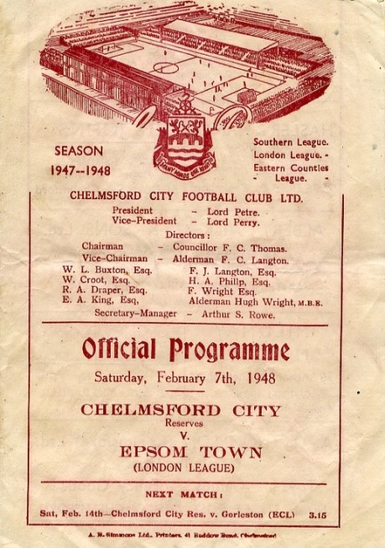
40 years ago this week a header from Phil Walker was sufficient to see us past Athenian League Hornchurch in our Fifth Round F.A. Vase tie. The Quarter Final would be at home against Addlestone.

17 years ago today we were defeated 1-0 at Hemel Hempstead Town in a League match. This was the first away league game in which we had failed to score since August 1995; a run of 48 straight away League games. Has anyone else EVER bettered this record? I doubt it.

2 years ago today we set another club record with our tenth straight League win on a Thursday night at Chessington & Hook United. It nearly went pear shaped as we led 3-0 with just four minutes remaining, but let two goals in and see an “equaliser” chalked off for offside. Scary! The record winning run would eventually reach 12.

First Eleven Appearances - (max 33 inc Molesey)
Name | Debut | 2014/15 |  |  |  | Career Totals
 |  | App | Sub | Total | Goals | App | Sub | Total | Goals
BROWN Oshane* | 30/08/2014 | 2 | 0 | 2 | 0 | 2 | 0 | 2 | 0
BURNS Robbie | 14/08/2007 | 0 | 1 | 1 | 0 | 202 | 15 | 217 | 121
COOPER-SMITH Daryl | 03/01/2015 | 4 | 0 | 4 | 1 | 4 | 0 | 4 | 1
CURRIE Sam | 04/08/2012 | 2 | 2 | 4 | 0 | 96 | 7 | 103 | 2
DEAN Dan | 02/08/2014 | 25 | 1 | 26 | 0 | 25 | 1 | 26 | 0
DEWAR Ali | 29/10/2011 | 5 | 6 | 11 | 3 | 55 | 35 | 90 | 10
DOUGLIN Karl* | 03/08/2013 | 1 | 0 | 1 | 1 | 41 | 3 | 44 | 14
DOWNS Carl* | 17/09/2011 | 4 | 1 | 5 | 0 | 94 | 13 | 107 | 2
EACOTT Michael | 02/08/2014 | 31 | 0 | 31 | 0 | 31 | 0 | 31 | 0
FARRELL Matt | 02/08/2014 | 28 | 3 | 31 | 3 | 28 | 3 | 31 | 3
FERDINANDO Matt | 20/09/2014 | 16 | 3 | 19 | 6 | 16 | 3 | 19 | 6
GAFFNEY Luke | 16/08/2014 | 10 | 1 | 11 | 0 | 10 | 1 | 11 | 0
HARPER Tommy* | 15/04/2014 | 1 | 0 | 1 | 0 | 2 | 1 | 3 | 0
HAYWARD Ben | 07/03/2007 | 6 | 0 | 6 | 0 | 242 | 28 | 270 | 18
HOADLEY Harry | 27/08/2011 | 6 | 1 | 7 | 0 | 7 | 1 | 8 | 0
HOUGH Kyle | 14/08/2007 | 28 | 2 | 30 | 16 | 282 | 14 | 296 | 153
JARMAN Mark | 08/08/2009 | 5 | 5 | 10 | 0 | 136 | 51 | 187 | 76
MARVELL Dale | 15/01/2000 | 11 | 5 | 16 | 5 | 261 | 45 | 306 | 85
MCGREGOR Alex | 08/08/2009 | 11 | 0 | 11 | 1 | 168 | 54 | 222 | 27
MCKAY Alex | 20/12/2008 | 7 | 4 | 11 | 1 | 72 | 26 | 98 | 8
MURPHY George | 28/03/2013 | 22 | 1 | 23 | 1 | 63 | 5 | 68 | 3
MUTIMA Lionel* | 05/08/2014 | 4 | 2 | 6 | 0 | 4 | 2 | 6 | 0
NELMES Elliott* | 05/08/2014 | 2 | 0 | 2 | 0 | 2 | 0 | 2 | 0
PANAYI Anthony | 14/11/2010 | 25 | 1 | 26 | 0 | 152 | 15 | 167 | 4
PANAYIOUTOU Savva | 03/01/2015 | 4 | 0 | 4 | 1 | 4 | 0 | 4 | 1
ROBINSON Matt | 01/12/2012 | 15 | 1 | 16 | 2 | 16 | 4 | 20 | 3
ROBINSON Sam | 22/10/2011 | 18 | 1 | 19 | 6 | 42 | 4 | 46 | 11
ROWE Steve | 27/08/2011 | 7 | 0 | 7 | 0 | 12 | 1 | 13 | 0
SHAW Ollie | 20/09/2014 | 0 | 10 | 10 | 0 | 0 | 10 | 10 | 0
SMITH Matt | 08/08/2009 | 0 | 1 | 1 | 0 | 91 | 43 | 134 | 10
SMITH Taylor* | 02/08/2014 | 13 | 2 | 15 | 7 | 13 | 2 | 15 | 7
TANTON Matt | 02/08/2014 | 18 | 4 | 22 | 1 | 18 | 4 | 22 | 1
TAYLOR James | 26/08/2013 | 26 | 1 | 27 | 2 | 43 | 7 | 50 | 3
VAN GELDER Julian* | 12/09/2006 | 0 | 1 | 1 | 0 | 0 | 2 | 2 | 0
WHITE Sean* | 02/08/2014 | 6 | 13 | 19 | 3 | 6 | 13 | 19 | 3
Own Goal |  |  |  |  | 1
* Player has left the club

Camberley Town – History
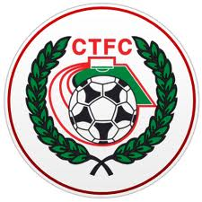
The football club was formed in 1895 at St. Michael’s Church in Yorktown and were named St. Michael’s, Camberley. They won their first trophy within two seasons beating Norwood & Selhurst 2-1 in the 1897-98 Surrey Junior Cup final. The club joined their first league, the East & West Surrey League, for the 1898-99 season and finished third.

In 1901 the club looked likely to fold and disappear due to the costs involved in running a football team but, after a public meeting, a new club named Camberley & Yorktown was formed by members of the St. Michael's committee thus maintaining a footballing presence in the area. Camberley & Yorktown took the place of St. Michael's in the East & West Surrey League before joining the Aldershot Combination in 1902 followed by the Ascot & District League in 1903 where the club won four titles and finished second three times in the seven years they spent in the league. The club went on to appear in three more Surrey Junior Cup finals, the first of which came in 1908 when Camberley & Yorktown took on Kingston at Woking and were beaten 2-0. The following season also resulted in a defeat in the final this time losing 1-0 to Selhurst Park. The1909-10 season saw victory at last as Camberley & Yorktown defeated Sutton United 2-1 at Kingston.

The club moved to the West Surrey League in 1910 and in 1913 made their first appearances in both the F.A. Cup and F.A. Amateur Cup. On September 13th 1913 Camberley & Yorktown played host to Sutton United and won 5-3 in their first F.A. Cup match. The first F.A. Amateur Cup game was disappointing though as Camberley & Yorktown were soundly beaten 7-0 by the Royal Army Medical Corps. However, the club went on to win the league title that season.

After World War I Camberley & Yorktown decided to concentrate their efforts on the Aldershot Senior League until 1922 when the club submitted an application to join the Surrey Senior League. This was accepted so Camberley & Yorktown became founder members of the league and remained in it for over 50 years. The club moved into their present ground at Krooner Park in 1923. The ground had been paid for from the winnings of a racehorse named 'Krooner' at Haydock Park in 1920. The 1930’s saw unequalled success at the club as they won the Surrey Senior League title three seasons running between 1930-31 and 1932-33 and appeared in the final of the Surrey Senior Cup in 1936 where they were beaten 3-1 by Wimbledon at Champion Hill, Dulwich.

After World War II Camberley & Yorktown dropped the 'Yorktown' part of their name as what had been two separate places when the name was first chosen had since merged to become one town. Krooner Park was not ready for use by the time the league resumed after the war so the club started the season at the London Road Recreation Ground which had been one of the grounds used before the move to Krooner Park. Success was hard to obtain with only a victory in the Surrey Senior Charity Cup in 1952 against Chertsey and a further appearance in the final of the same competition three seasons later to show for their efforts in the fifties and sixties.

In 1967 discussions took place between the two senior teams in the town, Camberley Wanderers and Camberley F.C. The two clubs decided that it made sense to merge and on 2nd June 1967 became Camberley Town F.C. The first decent season as Camberley Town came in 1972-73 when third place was achieved in the league and there was an appearance in the League Charity Cup final. They lost 3-2 to Westfield in the final at Weybridge. In their bid to bring a higher grade of football to the town the club joined the Spartan League in 1973 and installed floodlights in 1974. The official opening of the floodlights saw what is believed to be a record home attendance of around 3,500 people watch Camberley draw 1-1 with Malcolm Allison's Crystal Palace team.

In 1975 Camberley joined the Athenian League followed by the Isthmian League in 1977. Promotion to Division One of the Isthmian League was achieved in 1979 along with victory in the final of the Surrey Senior Cup where Leatherhead were beaten 4-1 after extra time at Imber Court. However, collapse soon followed and within three seasons Camberley found themselves back in the Athenian League and struggling on and off the pitch. Expansion of the Isthmian League in 1985 gave Camberley a route back into the league which was happily accepted.

In 1986 the Club enjoyed their best run in the F.A. Vase reaching the quarter finals where they went out to eventual winners Halesowen Town. The Aldershot Senior Cup was won in 1997 and 1998. 1997-98 also saw Camberley reach the Fourth Qualifying Round of the F.A. Cup equalling their best performance since the 1930's. In the league they missed out on promotion on the final day of the season. In 1998-99 Camberley went one better in the F.A. Cup reaching the First Round Proper for the first time where they were knocked out by Division 3 side Brentford.

With the disbanding of the Isthmian League Second Division in 2006 Camberley were placed in the Combined Counties League for the 2006-07 season and have since secured their best run of league placings for many years, and also winning the League Cup in 2008/09, by defeating Worcester Park 3-0 in the Final at Colston Avenue, home of Carshalton Athletic.
Current first team manager Dan Turkington took the helm during 2012-13 season. The club finished in second place in the league in 2014 which was their highest finish in any division since 1979. They also got to the final of the Aldershot Senior Cup but lost 4-3 to Alresford Town at Aldershot Town F.C.

The club's official website is www.camberleytownfc.co.uk and there's an active Twitter account at:
https://twitter.com/CamberleyTownFC

Centre page for results

Centre page for results

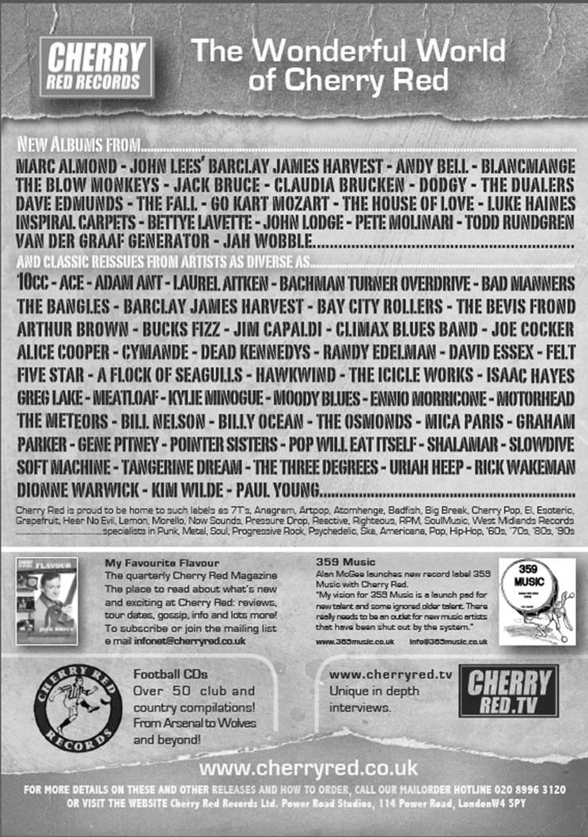

Player Sponsorship
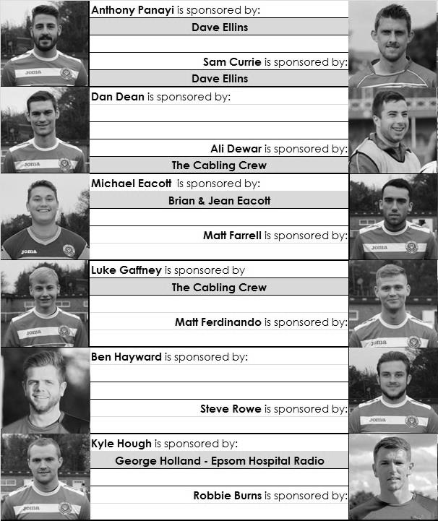

Here is the latest list showing all of the players and Management available for sponsorship. Sponsorship costs just £40 so if you want to help the club, the player and get your name in the programme for the season, let us know before they go!

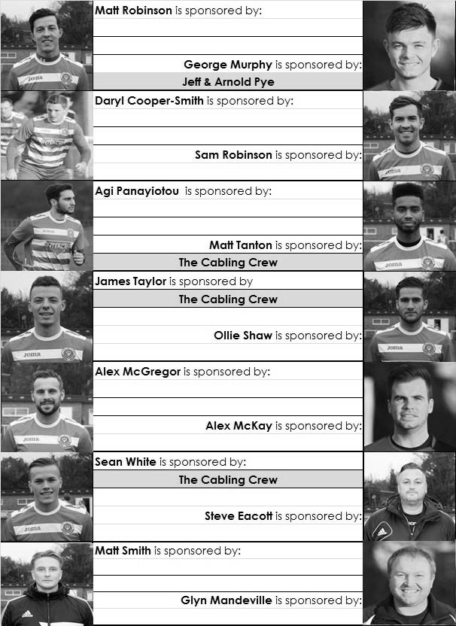

Every Opponent A-Z
Over the years we have played many, many different opponents. Exactly how many is a difficult question, as it all depends on your definition. Are Camberley & Yorktown different to Camberley Town, or are Epsom Town different to Epsom F.C. or Epsom & Ewell F.C.?

In my analysis I have classed them as the same team, and will work through them all from A to Z. Some we have played many times, whilst others we have met maybe just once or twice. Enjoy!

Metropolitan Police: Played 43 - W20 D7 L16 - F70 A74 - PPG - 1.56 - Above Average

People still find it strange that we should play a team at this level from the Metropolitan Police when every other “works” side has been eliminated from this level of football to my knowledge. Of course, all is not quite as it seems, as when I first started watching Epsom playing against them, they were restricted by the provision that you must be a police officer. Nowadays, this isn’t the case, which might explain why they are now an established Step Three team.

As with so many of our opponents, we actually started playing them far earlier than you might have thought. Our first ever meeting was way back on 12th November 1927 in an Amateur Cup tie at West Street. We were a decent outfit back then; two time Surrey Senior League Champions, and about to win the London League, but this did not affect them, and despite not being members of a League and just playing friendlies, they defeated us 3-0!

They joined the Spartan League in 1928 and we managed to squeeze past them in our next Amateur Cup meeting in the 1931/32 season when we were good enough to reach the Second Round Proper, but at Imber Court, their home since formation in 1919 they gained revenge the following season by knocking us out of both National Cups; two rounds short of the First Round Proper of the F.A. Cup (1-3) and in the final qualifying round of the Amateur Cup (2-5).

Results continued to favour the “Met”. We won a Surrey Charity Shield match in 1933, but were again knocked out of the F.A. Cup after a replay in 1935. They did it again later that same season in the Surrey Senior Cup by four goals to three and it was clear that they were becoming a bogey side, as we were pretty good ourselves in the thirties.

Our final pre-war meeting was another Surrey Senior Cup tie on 22nd January 1938 which we won 4-1 at West Street but following the war it was the same old problem as they won another F.A.Cup tie 5-0 at West Street in September of 1946.

We finally won another F.A. Cup tie 2-1 at Imber Court in September 1953 and didn’t then meet for five days short of ten years when they won a Surrey Senior Cup tie 3-1 in East Molesey. From that 1963 meeting we “lost touch” as they went through the Metropolitan and then Southern Leagues before arriving in the newly former Isthmian League Division Two for 1977/78. The two teams were at the top of the League throughout the season and we opened our floodlights against them on 24th August

1977, winning 1-0 and drawing the return 1-1 in February 1978. This made all the difference as we won the League title, while the Met Police were runners up.

Both teams spent six further seasons in competition as members of the Isthmian League Division One. We won the first six of these matches before losing four of the last six, including two 3-0 defeats in our promotion season of 1983/84. In the process ending our unbeaten home League run at 24 matches in March of 1984.

We came down again to Division One for 1986/87 but they were by then in Division Two South, having been relegated in 1984/85. We did meet in the Surrey Senior Cup though, edging through 2-1 at Imber Court. The following season it was their turn for success as they went up as Champions, only losing two games all season. We handed them their first defeat on the opening day of the season 22nd August 1987 when the weather was so bad that some games in the South East were abandoned! We trailed three times and led for just ten seconds, courtesy of Gary Greenaway’s long range strike in injury time. We then secured a 1-1 draw over there in February, although they did beat us 3-0 in the F.A. Cup, so you could say honours were even!

Despite them being at a higher level we knocked them out of the F.A. Cup 2-0 in September 1989 with the main memory being a Neil Robson strike before they knocked us out of the Associate Members Trophy (0-1) and the Surrey Senior Cup (1-2) in January 1997 and October 2000 respectively.

Our final four meetings came as members of the Isthmian League Division One South from 2002/03. We defeated them 1-0 on opening day and by the same score at Merland Rise but they won 5-2 at ours the following season although a great strike from youngster Craig Watkins nearly earned us a 2-1 win and we had to settle for a draw with a late equaliser before going down and never meeting since.

Since then they have had promotion to Step Three and recently reached the First Round of the F.A. Cup. At their excellent venue that of course these days now has a fourth floodlight pylon, things look well set for the Met.

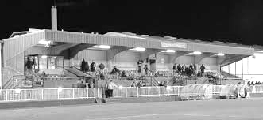
The main stand at Imber Court

EL Records Premier Challenge Cup
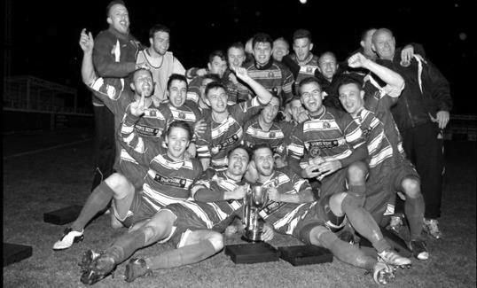
Second Round
Alton Town | 1-4 | Farnham Town
Ashford Town (Mx) | 5-0 | CB Hounslow United
Badshot Lea | 10-2 | Dorking
Bedfont Sports | 1-1+ | Cove
Cove won 4-1 on penalties
Camberley Town | 0-0+ | Molesey
Camberley Town won 3-0 on penalties
Chertsey Town | 0-7 | Windsor
Cobham | w/o Horley | Horley Town
Colliers Wood United | 3-0 | Bedfont & Feltham
Epsom & Ewell | 2-1 | Knaphill
Epsom Athletic | 0-5 | Banstead Athletic
Eversley & California | 2-4 | Ash United
Frimley Green | 1-0+ | Spelthorne Sports
Hanworth Villa | 2-3 | Guildford City
Sheerwater | 1-6 | Mole Valley SCR
Westfield | 4-0 | Farleigh Rovers
Worcester Park | 1-0 | Chessington & Hook United
Third Round
Westfield | 10/2 | Cove
Badshot Lea | 5-0 | Guildford City
Worcester Park | 6-1 | Banstead Athletic
Farnham Town | 2-0 | Mole Valley SCR
Frimley Green | 0-5 | Epsom & Ewell
Windsor | 8-1 | Ash United
Colliers Wood United | 3-2 | Horley Town
Camberley Town | 3-0 | Ashford Town (Mx)
Quarter Finals
Colliers Wood United | 25/2 | Badshot Lea
Worcester Park | 21/3 | Windsor
Epsom & Ewell | 24/2 | Camberley Town
Farnham Town | 3/3 | Westfield / Cove

Surrey Senior Cup
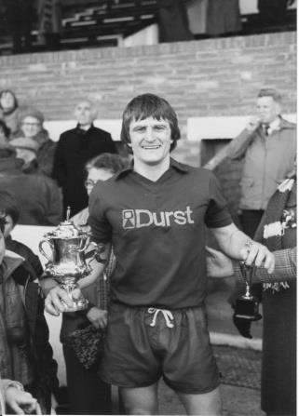
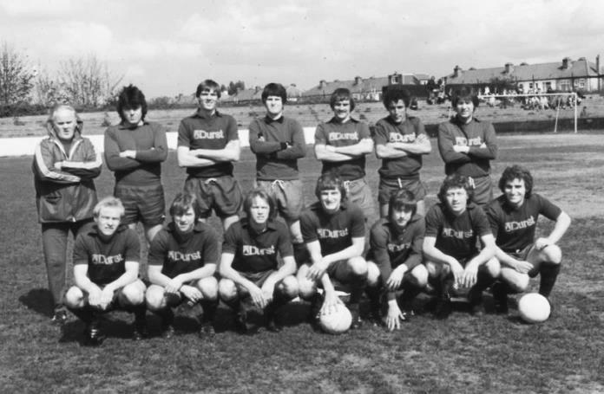
Second Round
Lingfield | 0-1 | Westfield
Redhill | 2-1 | Raynes Park Vale
Played at Raynes Park Vale
AFC Wimbledon | w/o Chipstead | Chipstead
Godalming Town | 2-4 | Mole Valley SCR
Knaphill | 0-3 | Colliers Wood United
Metropolitan Police | 1-0 | Walton & Hersham
Epsom & Ewell | 1-0 | Camberley Town
Leatherhead | 2-1 | Farnham Town
Merstham | 3-1 | Beckenham Town
Molesey | 1-0+ | Egham Town
South Park | 1-4 | Sutton United
Walton Casuals | 1-2 | Corinthian Casuals
Badshot Lea | 2-1 | Kingstonian
Dorking Wanderers | 9-0 | Frimley Green
Tooting & Mitcham United | 2-2+ | Horley Town
Tooting & Mitcham United won 4-2 on penalties
Woking | 0-3 | Ashford Town (Mx)
Third Round
Merstham | 2-1 | Sutton United
Redhill | 0-2 | Westfield
Dorking Wanderers | 3-4 | Colliers Wood United
Molesey | 3-1 | Epsom & Ewell
Leatherhead | 2-3 | Ashford Town (Mx)
Metropolitan Police | 3-0 | Chipstead
Tooting & Mitcham United | 3-1 | Mole Valley SCR
Corinthian Casuals | 17/2 | Badshot Lea
Quarter Finals
Ashford Town (Mx) | 17/2 | Westfield
Colliers Wood United | 18/2 | Merstham
Molesey | V | Corinthian Casuals / Badshot Lea
Met Police | 10/2 | Tooting & Mitcham United

F.A. Vase
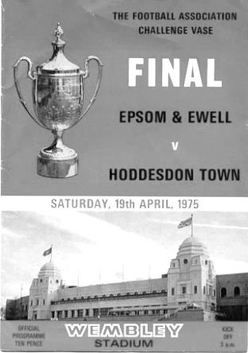
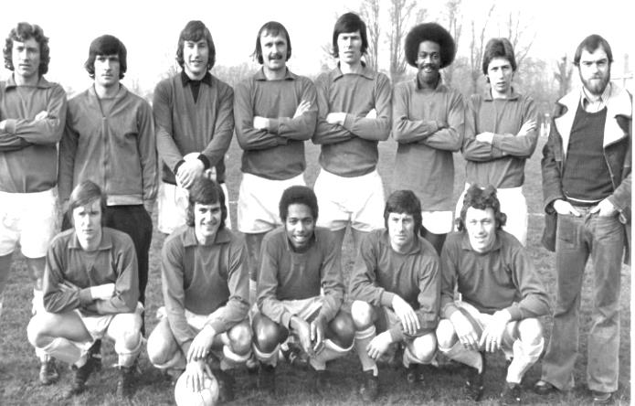
Fourth Round Results
Walsall Wood | 1-1+ r 1-4 | Shaw Lane Aquaforce
North Shields | 4-1 | Consett
Thurmby Nirvana | 3-4+ | Holbeach United
Chadderton | 0-5 | AFC Mansfield
Worksop Town | 0-1+ | Glossop North End
Heanor Town | 0-1 | Dunston UTS
Tadcaster Albion | 3-2 | Brocton
Bodmin Town | 0-2 | Phoenix Sports
Stanway Rovers | 1-0 | Saffron Walden Town
Ascot United | 4-2+ | Colliers Wood United
Bradford Town | 3-1 | Melksham Town
Ashford United | 0-5 | Norwich United
Greenwich Borough | 2-3 | AFC St Austell
Flackwell Heath | 3-0 | Hullbridge Sports
Highworth Town | 1-1+ r 2-2+ 4-2 pens | Tunbridge Wells
Erith & Belvedere | 1-0 | Yaxley
Fifth Round – 7th February
Bradford Town | V | Highworth Town
Western League |  | Hellenic League
AFC St Austell | V | Stanway Rovers
South Western Peninsula League (S6) |  | Eastern Counties League
Ascot United | V | Norwich United
Hellenic League |  | Eastern Counties League
Shaw Lane Aquaforce | V | Flackwell Heath
Northern Counties East League |  | Hellenic League
Glossop North End | V | Dunston UTS
North West Counties League |  | Northern League
Holbeach United | V | Erith & Belvedere
United Counties League |  | Southern Counties East League
North Shields | V | Phoenix Sports
Northern League |  | Southern Counties East League
AFC Mansfield | V | Tadcaster Albion
Northern Counties East League Division 1 (S6) |  | Northern Counties East League

CCL Premier Division Club Directory
ASHFORD TOWN (Mx) Telephone: 01784-245908 - Ground: The Robert Parker Stadium, Short Lane, Stanwell. TW19 7BH - Colours: Tangerine & White Stripes/Black/Tangerine

BADSHOT LEA Telephone: 01252-320385 - Ground: Ash United FC, Shawfield Stadium, Youngs Drive, Shawfields Road, Ash, Hampshire. GU12 6RE - Colours: Claret/White/Claret

BEDFONT SPORTS Telephone: 0208-831-9067 - Ground: Bedfont Sports Club, Hatton Road, Bedfont, Middx TW14 8JA - Colours: Red & Black Hoops/Black/Red & Black Hoops

CAMBERLEY TOWN Telephone: 01276-65392 - Ground: Krooner Park, Wilton Road, Camberley, Surrey. GU15 2QW - Colours: Red & White Stripes/Blue/Red

CHERTSEY TOWN Telephone: 01932-561774 - Ground: Alwyns Lane, Chertsey, Surrey. KT16 9DW - Colours: Royal Blue & White Stripes/Royal Blue/Royal Blue

COLLIERS WOOD UNITED Telephone: 0208-942 8062 - Ground: Wibbandune Sports Ground, Lincoln Green, Opposite 199-213, Robin Hood Way, Wimbledon. SW20 0AA - Colours: Blue & Black Stripes/Black/Black

COVE Telephone: 01252-543615 - Ground: Oak Farm Fields, 7 Squirrel Lane, Cove, Farnborough, Hampshire. GU14 8PB - Colours: Yellow/Black/Yellow

EPSOM & EWELL Telephone: 01737-553250 - Ground: Chipstead FC, High Road, Chipstead, Surrey. CR5 3SF - Colours: Royal Blue & White Hoops/Royal Blue/Royal Blue & White Hoops

FARNHAM TOWN Telephone: 01252-715305 Ground: Memorial Ground, Babbs Mead, West Street, Farnham, Surrey. GU9 7DY Colours: - Claret & Sky Blue /White/ Claret & Sky Blue

FRIMLEY GREEN Telephone: 01252-835089 - Ground: Frimley Green Recreation Ground, Frimley Green Road, Frimley Green, Camberley, Surrey. GU16 6JY - Colours: Blue & White/Blue/Blue

GUILDFORD CITY Telephone: 01483-443322 - Ground: The Spectrum, Parkway, Guildford, Surrey. GU1 1UP - Colours: Red & White Stripes/Black/Black

HANWORTH VILLA Telephone: 0208-831-9391 - Ground: Rectory Meadows, Park Road, off Hounslow Road, Hanworth, Middlesex. TW13 6PN - Colours: Red & White Stripes/Black/Black

HARTLEY WINTNEY Telephone: 01252-843586 - Ground: Memorial Playing Fields, Green Lane, Hartley Wintney, Hants RG27 8DL - Colours: Orange & Black/ Orange /Orange

HORLEY TOWN Telephone: 01293-822000 - Ground: The New Defence, Anderson Way, Court Lodge Road, Horley, Surrey. RH6 8SP - Colours: Claret & Sky Blue/Claret/Claret

KNAPHILL Telephone: 01483-475150 - Ground: Brookwood Country Park, Redding Way, Lower Guildford Road, Knaphill, Surrey. GU21 2AY - Colours: Red/Black/Red

MOLE VALLEY SCR Telephone: 01932-866386 - Ground: Cobham FC, Leg O’Mutton Field, Anvil Lane, Downside Bridge Road, Cobham, Surrey KT11 1AA - Colours: Yellow/Black/Black

MOLESEY Telephone: 0208-979-4283 - Ground: 412 Walton Road, West Molesey, Surrey KT8 2JG - Colours: White/Black/Black

RAYNES PARK VALE Telephone: 020-8540-8843 - Ground: Prince Georges Playing Field, Grand Drive, Raynes Park, London. SW20 9NB - Colours: Blue/Blue/Red

SPELTHORNE SPORTS Telephone: 01932-961055 - Ground: Spelthorne Sports Club, 296 Staines Road, Ashford Common, Ashford, Middx. TW15 1RY - Colours: Light & Dark Blue/Dark Blue/Light Blue

WESTFIELD Telephone: 01483-771106 - Ground: Woking Park, Kingfield Road, Woking, Surrey. GU22 9BA - Colours: Yellow/Black/Black

WINDSOR Telephone: 01753-860656 - Ground: Stag Meadow, St Leonards Road, Windsor, Berks SL4 3DR - Colours: Red/Red/Red

Match and Ball Sponsorships – 2014/15
Opponent | Date | Match Sponsor | Ball Sponsor
Raynes Park Vale | 05/08/14 | Club President - Stella Lamont
Horley Town | 25/08/14 | EEFC Management Committee
Croydon (FAC) | 30/08/14 | EEFC Media Officer - Richard Lambert
Frimley Green | 13/09/14 | Dave Gaffney and friends
Guildford City | 30/09/14 | The Jarman family
Mole Valley SCR | 07/10/14 | Mark and Carmel Murphy
Bedfont Sports | 11/10/14 | Epsom & Ewell F.C. Colts
Knaphill (LC) | 14/10/14 | Geoff and Steve Dyke
Ashford Town (Mx) | 18/10/14 | The Building Shop, Bookham
Chertsey Town | 28/10/14 | In Memory of Bob Bexley
Molesey | 22/11/14 | The Cabling Crew 0208 -224 4110
Camberley Town (SSC) | 02/12/14 | In memory of Liz and Doug Burns
Spelthorne Sports | 16/12/14 | long serving supporter Paul Merritt
Windsor | 03/01/15 | Ezara Beddoe
Farnham Town | 17/01/15 | In memory of Chris Henry
Camberley Town | 07/02/15 | Former player Marvin Hough
Hartley Wintney | 21/02/15
Camberley Town (LC) | 24/02/15
Hanworth Villa | 03/03/15
Cove | 07/03/15
Badshot Lea | 21/03/15
Westfield | 24/03/15
Colliers Wood United | 04/04/15
Knaphill | 18/04/15
For League, League Cup and Surrey Senior Cup Matches:

Match sponsorship - £40.00 Match ball sponsorship - £25.00.
Combined Offer of Match and Match Ball sponsorship for £55.00.

For F.A. Cup and F.A. Vase matches:

Match sponsorship - £50.00 Match ball sponsorship - £30.00.
Combined Offer of Match and Match Ball sponsorship for £65.00.
----------------------------------------------------------------------------------------------------------------------------
Sponsorship includes

Admission, programmes, advertising (if required) and hospitality.

If you are interested, just speak to a Committee Member, you know where we are!
Alternatively, drop me an email at: richard.c.lambert@gmail.com

Salts Super Six Predictor
The Salts Super Six Predictor is live again. The next matches are TODAY and tickets are on sale at today’s game to the left of the gate.

The competition is easy to play and you don’t even have to be at the match! To win, you simply need to predict the results of six matches correctly from the three options, fill in the form and make sure it is back with one of our distributors before the deadline on the ticket. The latest fixtures are shown here. Last week we had TEN entrants with five winning results so it surely won’t be long…

If you are a club regular, you just need to place your name on the sheet, although if you aren’t, then we’ll need a contact number from you too. We will announce any winners on the website within three working days, so don’t worry, we won’t miss you!

The prize pot is currently £195 but will continue to go up, if unclaimed, by the cost of 50% of all the sold tickets. In other words, if we sell 100 tickets at £2 before the deadline, and the pot isn’t won, then the next prize would be £295! You’ll always know the size of the pot before you enter.

Please note that if there is more than one winner, the prize pot would be shared between the winners. All you need to do now is have a go, as many times as you like!

Good luck!

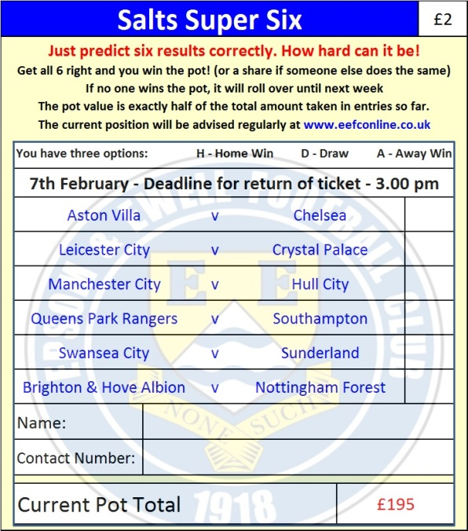

Combined Counties League – Premier Division
Saturday, 7th February 2015 - Kick-off 3.00 p.m.
Epsom and Ewell  (Royal Blue & White hoops) | V |  | Camberley Town  (Red and White Stripes)
 | NUMBERS
Michael Eacott |  |  | Craig Bradshaw
James Taylor |  |  | Matthew Humphrey
Steve Rowe |  |  | Carl Garstang
Anthony Panayi |  |  | Nick Sowden
George Murphy |  |  | Doug Ford
Dan Dean |  |  | Daniel Jewell
Matt Ferdinando |  |  | Freddie Kelsey
Matt Farrell |  |  | Matthew Bunyan
Kyle Hough |  |  | Emmanuel Quarshie
Alex McGregor |  |  | Perry Coles
Matt Robinson |  |  | Jamie Hoppitt ©
Daryl Cooper-Smith |  |  | Dave Hill
Alex McKay |  |  | Sam Slater
Sam Robinson |  |  | Jon Burch
Matt Tanton |  |  | Dean Greenwood
Savva ‘Agi’ Panayiotou |  |  | Marcus Cousins
Sam Currie |  |  | Brad Smith
Ali Dewar
Robbie Burns
Ben Hayward
Glyn Mandeville | MANAGER |  | Dan Turkington
Matt Smith | ASSISTANT
Steve Eacott / Alex McKay | COACHES |  | Dean Greenwood, Sam Rafique
Ken Jones | PHYSIO
REFEREE: D.Hayes (East Sheen)
ASSISTANTS: J.Lidbetter (Surbiton), M.Stevens (Morden)
Today’s Match and Match Ball are sponsored by
former player Marvin Hough, father of Kyle

OUR NEXT VISITORS TO HIGH ROAD
Hartley Wintney
Saturday 21st February 2015 - Kick-off 3.00 p.m.
Combined Counties League – Premier Division

